From the dashboard, click the Reporting tab and select Electronic Documents from the dropdown menu.

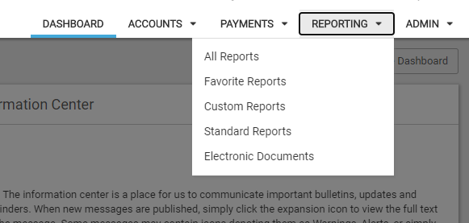

On the next page, select the Sign Up/Changes tab.



This will show a list of all the accounts. You can select the check box next to “Enroll All Available Accounts and Document Types Shown” or select the check boxes next to the individual accounts shown in the list. The  will expand the documents list for each account and allow them to select certain documents if they do not want everything.